Peak Oil
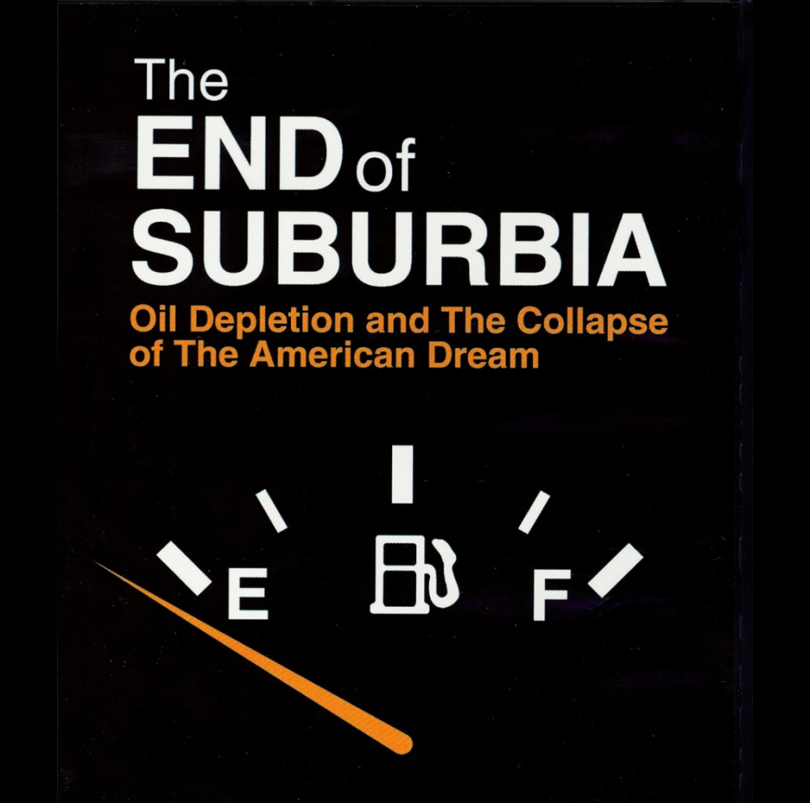

Must see documentary on oil peak.

www.endofsuburbia.com

When: 3pm, Saturday 4th of July, 2005
What: Part of the World Environment Day Festival - www.ecoaction.net.au
Where: The Rocks Meeting Room, The Rocks, Acton

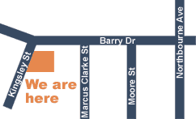

ACT Peak Oil Group

Find out when we meet and check our website:

: http://act-peakoil.org/
contact: alex-po@trevbus.org

